Capstone Project by Imran Tan
Credit Card Fraud Detection Using Machine Learning

Opportunity statement

Background

In a survey conducted by Statista in Singapore on December 2019, 77% of respondents noted to have chosen credit cards as their main choice of payment for e-commerce transactions. Also, noted that there have multiple cases of credit card fraud occurring and the various new methods in which credit card fraud are being performed. Here’s an overview on the different types of credit card fraud:

- Card-present (CP) scenarios - refer to scenarios where a physical card is needed.
- Lost or stolen card
- Counterfeited card
- Card not received

- Card-not-present (CNP) scenarios - refers to scenarios where a physical card does not need to be used.
- Illegally obtained payment credentials via phishing, scam text message

Hence, financial institutions would have in place a fraud detection system to detect such fraudulent transactions. However due to the rapid growth in the amount of data, it is becoming increasingly difficult for a human specialist to detect meaningful patterns from transaction data. In the last couple of years, credit card fraud detection (CCFD) has been increasingly complemented with computer algorithms known as Machine Learning (ML), which allow to search and detect patterns from large amounts of data. ML algorithms have been shown to significantly improve the efficiency of fraud detection systems and assist fraud investigators in detecting fraudulent transactions. However, the field of ML for CCFD is relatively new, and there does not exist any recognized benchmarks, nor methodologies at this moment.

Fraud Detection Systems
Below is an overview of a fraud detection system:
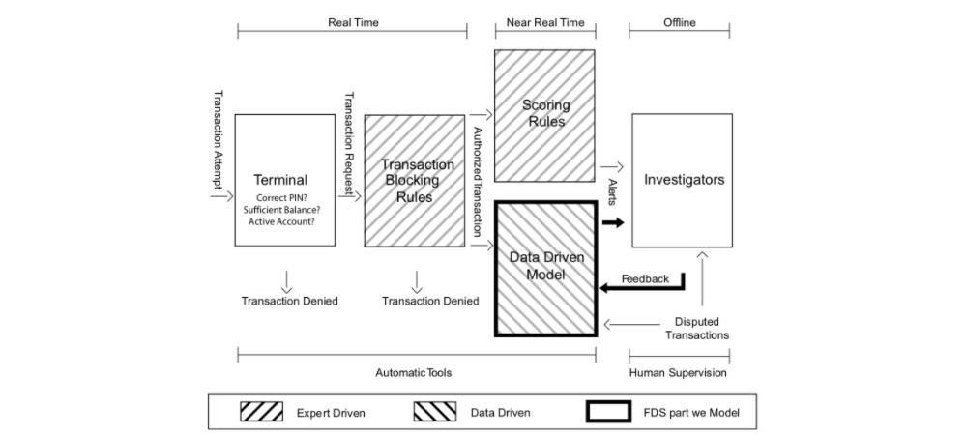

Here is a summary on the model above:

- First layer: The terminal represents the first control layer in an FDS and performs conventional security checks on all the payment requests
- Second layer: Transaction-blocking rules are if-then (-else) statements meant to block transaction requests that are perceived as frauds.
- Third layer: Scoring rules are manually designed by investigators, which arbitrarily define their associated scores. An example of a scoring rule can be “IF previous transaction in a different continent AND less than one hour from the previous transaction THEN fraud score = 0.95”.
- Fourth layer: The Data Driven Model will be where our machine learning model comes into play and is used to estimate the probability for a transaction to be fraudulent. The model is expected to find frauds according to rules that go beyond investigator experience.
- Fifth layer: Investigators are professionals experienced in analysing credit card transactions and are responsible for the expert-driven layers of the fraud detection system.

What is the opportunity the project is investigating?
As mentioned above that there does not exist any recognized benchmarks or methodologies now, there is an opportunity to propose a simple pipeline for ML in a fraud detection system. The project is to showcase a baseline model for fraud detection, which can be easily reproducible and potentially act as a basis of comparison against more sophisticated models.

Stakeholders
Who are the stakeholders?
The primary stakeholders are students or professionals in financial institutions and investigators who are interested in the specific problem of credit card fraud detection from a practical point of view.

Business question

What is the main business question that needs to be answered?

How to use machine learning for credit card fraud detection?

Business value estimate
The business value here would be a simple reproducible model for fraud detection, which can act as a baseline model to compare against much more sophisticated models for businesses.

Data

Data sources
The data being used is a simulated data containing legitimate and fraudulent transactions.

Features of the data
In essence, a payment card transaction consists of any amount paid to a merchant by a customer at a certain time. The six main features that summarise a transaction therefore are:
- The transaction ID: A unique identifier for the transaction
- The date and time: Date and time at which the transaction occurs
- The customer ID: The identifier for the customer. Each customer has a unique identifier
- The terminal ID: The identifier for the merchant (or more precisely the terminal). Each terminal has a unique identifier
- The transaction amount: The amount of the transaction.
- The fraud label: A binary variable, with the value 0 for a legitimate transaction, or the value 1 for a fraudulent transaction.

These features will be referred to as TRANSACTION_ID, TX_DATETIME, CUSTOMER_ID, TERMINAL_ID, TX_AMOUNT, and TX_FRAUD.

What is the quality of the raw data?
The data is of good quality, with no null or missing values. However it is highly imbalanced with 199,306 genuine transactions compared to only 1835 fraudulent transactions. For the data we are focusing on for our model for the period of 25th Aug 2018 to 14th September 2018, there is a total of 201,141 transactions. However this imbalance is intentionally simulated as to mimic a real-world transaction dataset in which we expect majority of the transactions to be genuine. Note that, although the full data is from 1 Apr 2018 to 30 Oct 2018, we will be dealing with a portion of the data for the baseline model and more of the data will be included for validation testing.

Data science process

Data analysis

Highlights of the Exploratory Data Analysis (EDA)
From the exploratory data analysis, the following insights onto the simulated datasets are obtained:
- For the time period of of 25th Aug 2018 to 14th September 2018, there is a total of 201,141 transactions.
- 199,306 genuine transactions and 1835 fraudulent transactions
- 1,614 fraudulent credit cards
- The data frame consist of 201,141 rows × 23 columns
- From the plot below, shows that the ratio between genuine and fraudulent transactions are generally the same from day to day.
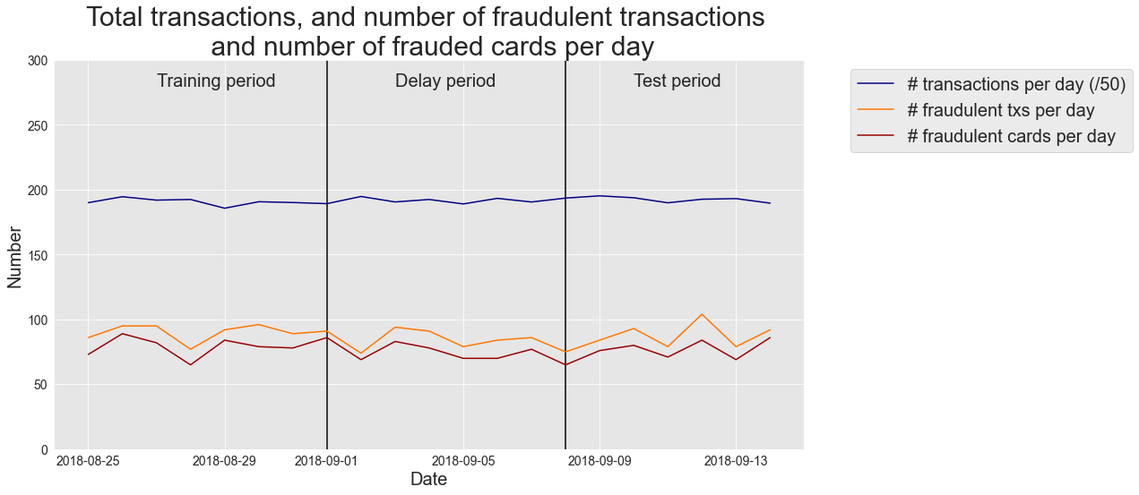

Fraud scenarios in the data
The dataset consists of the following fraud scenarios:
- Scenario 1: Any transaction whose amount is more than 220 is a fraud. This scenario is not inspired by a real-world scenario. Rather, it will provide an obvious fraud pattern that should be detected by any baseline fraud detector. This will be useful to validate the implementation of a fraud detection technique.

- Scenario 2: Every day, a list of two terminals is drawn at random. All transactions on these terminals in the next 28 days will be marked as fraudulent. This scenario simulates a criminal use of a terminal, through phishing for example. Detecting this scenario will be possible by adding features that keep track of the number of fraudulent transactions on the terminal. Since the terminal is only compromised for 28 days, additional strategies that involve concept drift will need to be designed to efficiently deal with this scenario.

- Scenario 3: Every day, a list of 3 customers is drawn at random. In the next 14 days, 1/3 of their transactions have their amounts multiplied by 5 and marked as fraudulent. This scenario simulates a card-not-present fraud where the credentials of a customer have been leaked. The customer continues to make transactions, and transactions of higher values are made by the fraudster who tries to maximize their gains. Detecting this scenario will require adding features that keep track of the spending habits of the customer. As for scenario 2, since the card is only temporarily compromised, additional strategies that involve concept drift should also be designed.

Modelling

Features Selection
We will create two new binary features from the transaction dates and times:

The first will characterize whether a transaction occurs during a weekday (value 0) or a weekend (1), and will be called TX_DURING_WEEKEND

The second will characterize whether a transaction occurs during the day or during the day (0) or during the night (1). The night is defined as hours that are between 0pm and 6am. It will be called TX_DURING_NIGHT.

For the TX_DURING_WEEKEND feature, we define a function is_weekend that takes as input a Panda timestamp, and returns 1 if the date is during a weekend, or 0 otherwise. The timestamp object conveniently provides the weekday function to help in computing this value.

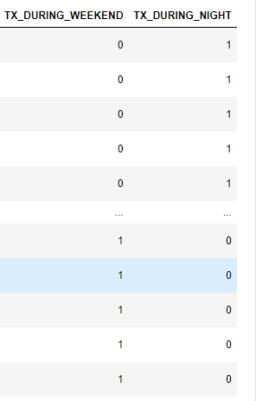

For customer ID transformations will be the number of transactions that occur within a time window. The second will be the average amount spent in these transactions. The time windows will be set to one, seven, and thirty days. This will generate six new features.

Let us implement these transformations by writing a get_customer_spending_behaviour_features function. The function takes as inputs the set of transactions for a customer and a set of window sizes. It returns a DataFrame with the six new features.

Our implementation relies on the Panda rolling function, which makes easy the computation of aggregates over a time window.
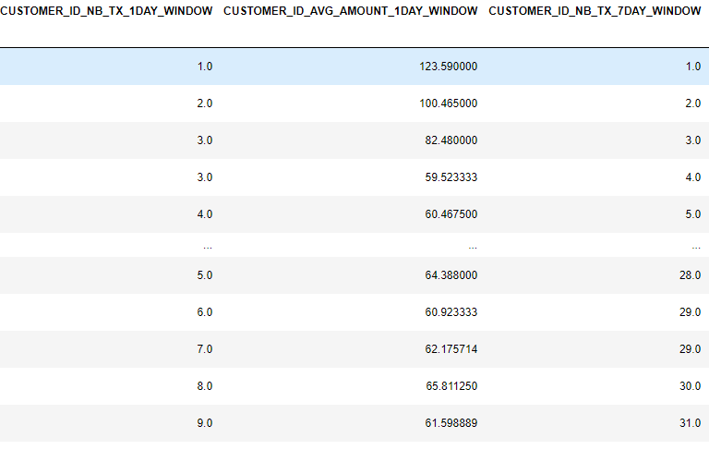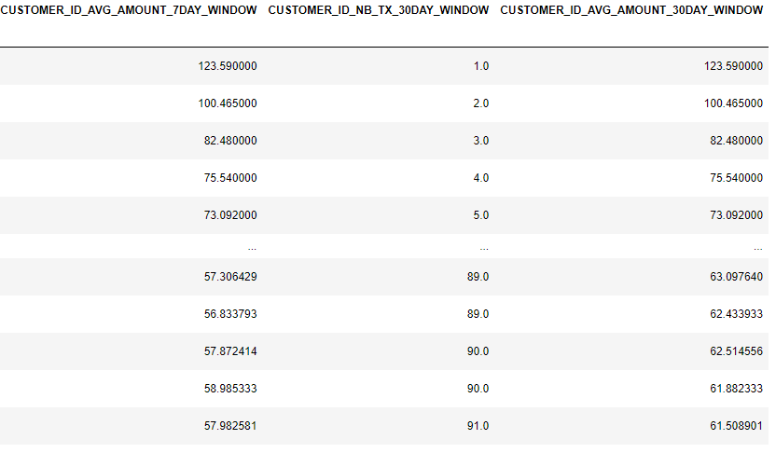

Finally, for the terminal ID transformations, the main goal will be to extract a risk score, that assesses the exposure of a given terminal ID to fraudulent transactions.

The risk score will be defined as the average number of fraudulent transactions that occurred on a terminal ID over a time window. As for customer ID transformations, we will use three window sizes, of 1, 7, and 30 days.

Contrary to customer ID transformations, the time windows will not directly precede a given transaction. Instead, they will be shifted back by a delay period. The delay period accounts for the fact that, in practice, the fraudulent transactions are only discovered after a fraud investigation or a customer complaint. Hence, the fraudulent labels, which are needed to compute the risk score, are only available after this delay period. To a first approximation, this delay period will be set to one week.

The computation of the risk scores by defining a get_count_risk_rolling_window function. The function takes as inputs the DataFrame of transactions for a given terminal ID, the delay period, and a list of window sizes.

In the first stage, the number of transactions and fraudulent transactions are computed for the delay period (NB_TX_DELAY and NB_FRAUD_DELAY).

In the second stage, the number of transactions and fraudulent transactions are computed for each window size plus the delay period (NB_TX_DELAY_WINDOW and NB_FRAUD_DELAY_WINDOW).

The number of transactions and fraudulent transactions that occurred for a given window size, shifted back by the delay period, is then obtained by simply computing the differences of the quantities obtained for the delay period, and the window size plus delay period:

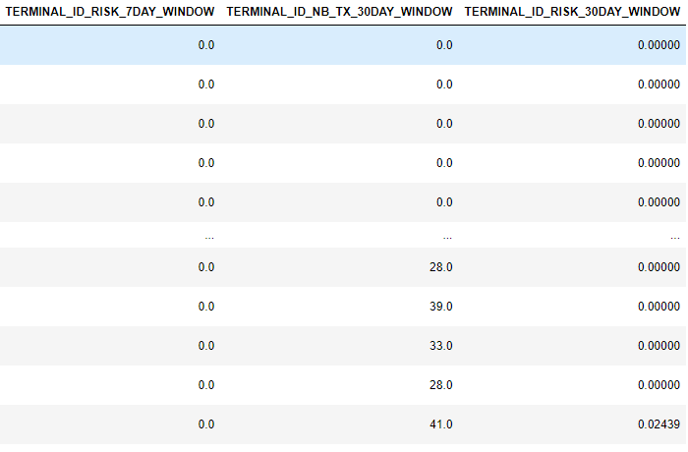

Training and test data
I have chosen our test set to take place one week after the last transaction of the training set. In a fraud detection context, this period separating the training and test set is referred to as the delay period or feedback delay.

It accounts for the fact that, in a real-world fraud detection system, the label of a transaction (fraudulent or genuine) is only known after a customer complaint, or thanks to the result of a fraud investigation.

Therefore, in a realistic scenario, the annotated data available to train a model and start making prediction for a given day are anterior to that day minus the delay period. Setting a delay period of one week is simplistic. It assumes that the labels (fraudulent or genuine) for all transactions are known exactly one week after they occurred.

This is in practice not the case, since the delay may be shorter when customers report frauds quickly, or much longer in cases where frauds remain undetected for months. The delay period is in fact a parameter in the assessment of a fraud detection model. A one-week delay is to a reasonable basis. For simplicity of our baseline model, we will be working on this assumption for the project.

Models used

For this project I had selected 4 different models to be used. Logistic Regression and Decision Trees were chosen for their simplicity. Random Forest and boosting techniques chosen due to them being very popularly used in the industry.

Model performance metrics

Why is accuracy not a good measure?
Accuracy is a poor performance metric, due to the cost-sensitive and imbalanced nature of a fraud detection problem. A simple way to illustrate this is to observe that, for a transaction dataset with 0.1% fraudulent transactions, a dummy baseline model classifying all the transactions as genuine provide a very high accuracy of 0.99.

Which measures to use?
Thee AUC ROC and Average Precision (AP) metrics aim at assessing, with a single number, the performance for all possible decision thresholds. The AUC ROC is currently the de-facto metric for assessing fraud detection accuracies. However, recent research has shown that this metric is also misleading for assessing highly imbalanced problems such as fraud detection, and recommended using the Precision-Recall curve and AP metric instead. For this project I have relied on AUC ROC and AP for the metrics to determine which model performs best.

Results

Training results:
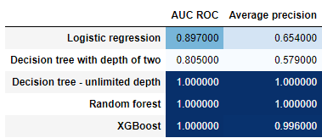

Test results:
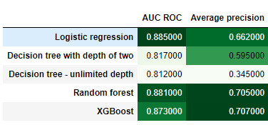

Execution times:
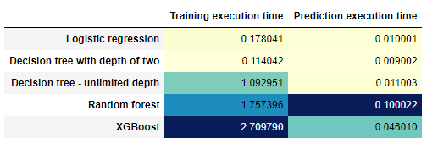

The main takeaways in these performance results:

- All prediction models have learned useful fraud patterns from the training data. This can be seen from the AUC ROC on the test set, which is higher than 0.5 for all classifiers, and an average precision much higher than 0.007.

- The random forest and XGBoost provide better performances (in terms of Average Precision) than logistic regression and decision trees.

- The relative performances of the classifiers differ depending on which performance metrics is used. For example, a decision tree of depth 2 has a lower AUC ROC than a decision tree of unlimited depth, but a higher average precision.

- The performance of some classifiers (Random Forest and Decision Tree with unlimited depth) is perfect on the training set (AUC ROC and Average Precision of 1), but lower on the test set. In fact, the decision tree with unlimited depth is actually the worst classifier on the test set in terms of Average Precision. This is due to overfitting.

- The execution times for training ensembles of models (Random forest and XGBoost) is significantly higher than decision trees and logistic regression.

AUC, ROC Curve and Precision-Recall Curve

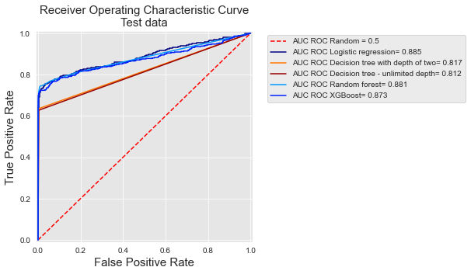
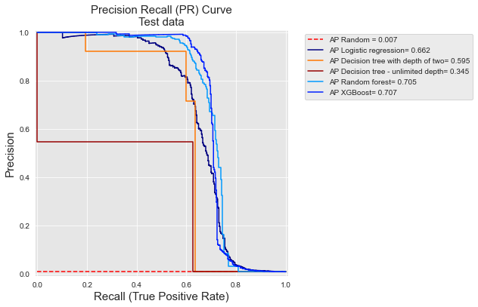

Which model was selected?

Before I settled for a model from the results above, I had performed validation on the model results and hyperparameter tuning to obtain better and more reliable results. Thus, finding out which model is best.

Model validation technique
The scheme is called prequential validation. An alternative validation procedure consists in using training sets of similar sizes, taken from older historical data. Each fold shifts the training and validation sets by one block in the past. See below for a visualisation:

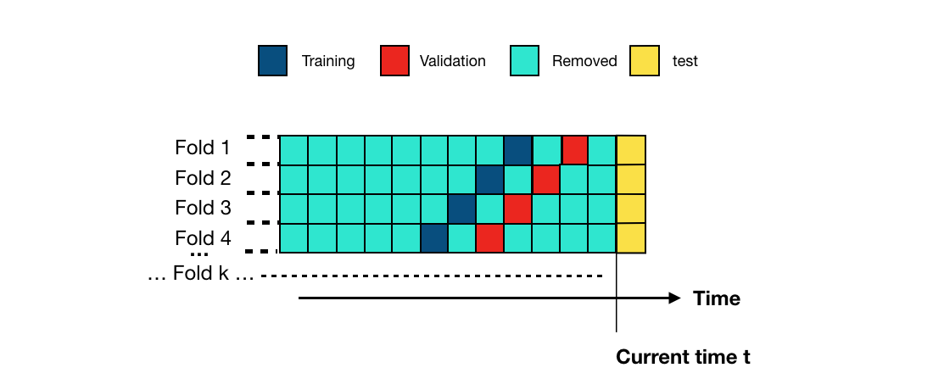

Hyperparameter tuning
I compared the performances in order to determine which model class provides the best performances.
For each model class, let us retrieve the performance for three types of parameters:
- Default parameters: Default parameters that sklearn gives to a model class. The default parameters for each model class are:
  - Decision tree: max_depth=None.
  - Logistic regression: C=1.
  - Random forest: n_estimators=100, max_depth=None.
  - XGBoost: n_estimators=100, max_depth=2, learning_rate=0.1.
- Best estimated parameters: Parameters that provide the highest performances on the validation set.
- Optimal parameters: Parameters that provide the highest performances on the test set.

Final results
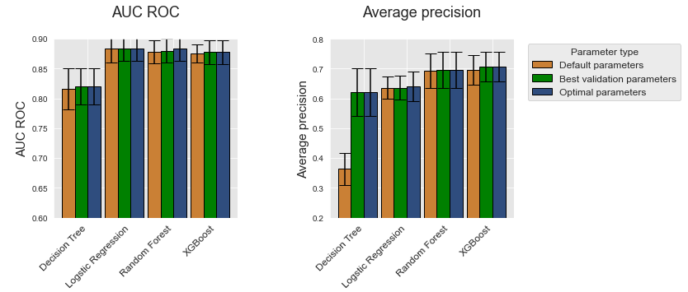

On this simulated dataset, XGBoost provides the highest performances, followed by random forest, logistic regression, and finally decision trees which have the lowest performances. The gap in terms of performance is most visible with the average precision metric. The performances of logistic regression, random forest, and XGBoost are very similar in terms of AUC ROC.

Conclusion

What is the key takeaway from this project?
The proposed deployment of basic pipeline for credit card fraud detection have identified the following:
- Using basic and essential information on transactions can help us greatly in Machine Learning for credit card fraud detection.
- Understanding the different fraud scenarios happening in the real-world can assist us in feature engineering.
- The best model for credit card fraud detection depends on the data available and identifying what are the metrics of importance which are applicable for the business environment.
The steps in the deployment of the basic are:
- Extract, transform and load the transaction data – understand the essential features
- Engineer features - perform feature engineering on the essential features based on suspected and common fraud scenarios and patterns.
- Identify – what are the metrics of importance (ROC, AUC or Precision-Recall)
- Validation & Tuning – Perform cross validation on the model and hyperparameter tuning to obtain the best performing model
- Analyse - Finally, analyse the results and use the best model to detect fraudulent transactions on future transactions.

Further work/Other considerations
There is a range of possible further work that can be undertaken:
- Consider the usage of deep learning tools (neural networks) as a machine learning classifier in the future.
- Consider other metrics such as the Card Precision top-k, which was proposed by the The Machine Learning Group. (I have included this metric in my notebook for comparison.)
- Consider practicality in the usage of the models. Seems like the better performing models take significantly longer execution times.
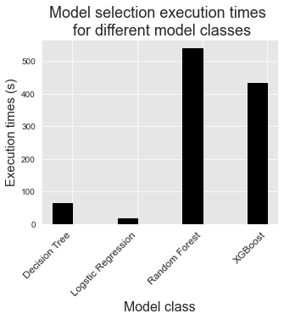

References

Resources
https://www.statista.com/statistics/1028439/singapore-most-popular-payment-methods-for-online-purchase/
https://fraud-detection-handbook.github.io/fraud-detection-handbook/Chapter_1_BookContent/BookContent.html

Data Files
simulated-data-raw
simulated-data-transformed

Notebooks
Capstone project final - Feature transformation
Capstone - Analysis (Final)

